Create a three fold brochure for Northside Suziki

Open InDesign and create a two page 3 Fold Brochure using the following settings (unlock Bleed and set bleed at 2 (Tab to each)
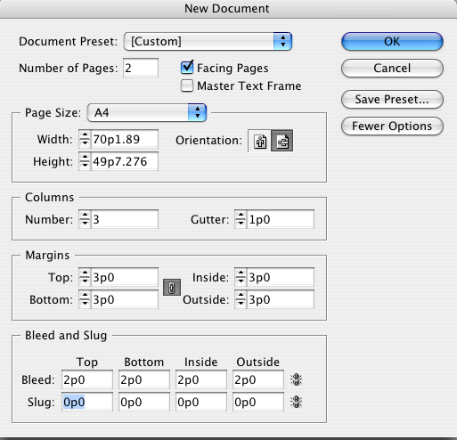

Your spread should look like this
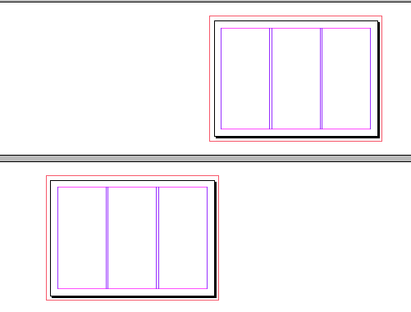

Click on Pages and select Master

Place a background image 303 Yallingup, Canal Rocks2.jpg from the InDesign Data files and fit it to the whole page

Make this transparent about 30% Your spread should look like this
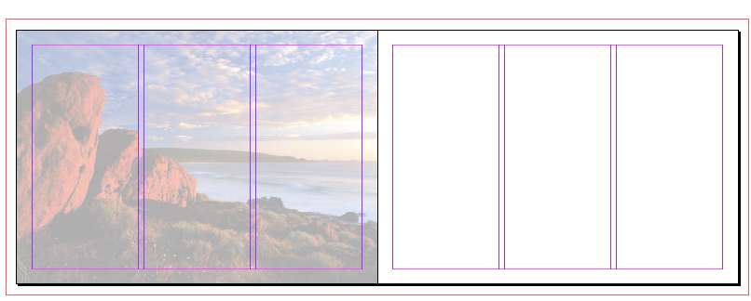

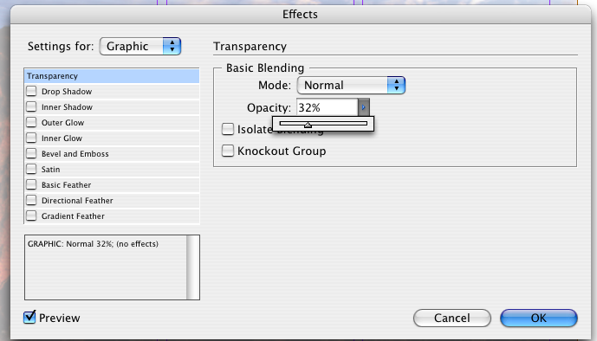

Add a background the B Master
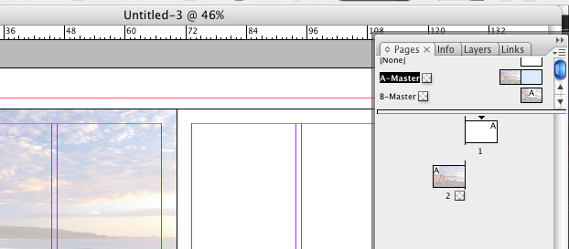
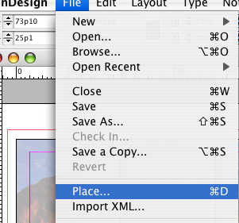

Place another image

303 Bunker Bay.jpg

Make this transparent 30%
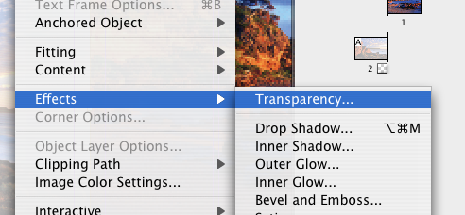
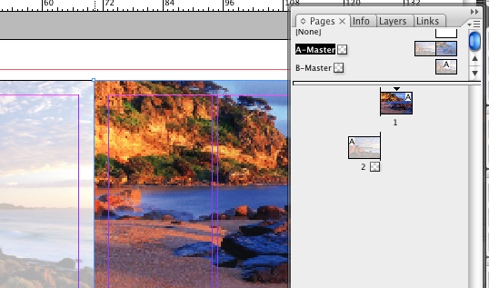

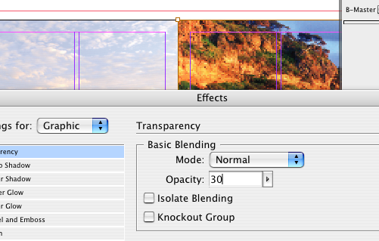

Transparency

Transparency

Type 30 in the Opacity window = 30%

Now your task is to add other elements to make a three fold brochure
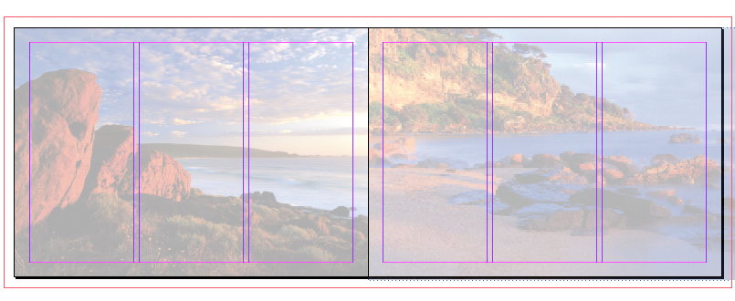

This is your face page Fold a piece of A4 Landscape to get the feel for how your brochure will fold, mark back pages

Choose Text Frame Options from the Object menu. Set the Top, Bottom, Left, and Right Inset Spacing to .25″. If the little chain icon is enabled, setting one measurement makes all measurements the same. Click OK. Now that you’re back to your text frame, double-click on it with the Selection tool to switch to the Type tool and key in your headline.


Need help just ask

